# **Java Project Report**

# **Billing System**

Name: Narendra Raju Mali

Roll No.: B222

Sap Id: 70022100355

Name: Swaraj Borkar

Roll No.: B232

Sap Id: 70022100443

Name: Medimi Pratyush

Roll No.: B229

Sap Id: 70022100434

Under the Guidance of

Prof.Bhushan Inje Sir

**ABOUT THE PROJECT:**

**A simple billing system is a software program designed to help businesses manage their invoicing and payment processes. It typically includes features such as creating and sending invoices, tracking payments and overdue balances, and generating reports. The system can be used by businesses of all sizes to streamline their billing processes and ensure timely payments from customers. With a simple billing system, businesses can reduce the time and effort spent on manual invoicing and payment tracking, and focus on growing their business instead. Some billing systems may also integrate with accounting software and payment gateways to provide a more comprehensive solution for managing financial transactions.**

**USING OF JAVA SWING IN THE PROJECT:  
Java Swing is a graphical user interface (GUI) toolkit that is part of the Java Standard Edition (Java SE) platform. It provides a set of components that developers can use to create desktop applications with rich, interactive user interfaces. Swing includes a wide range of components such as buttons, text fields, labels, tables, and more, which can be easily customized to suit the needs of the application.**

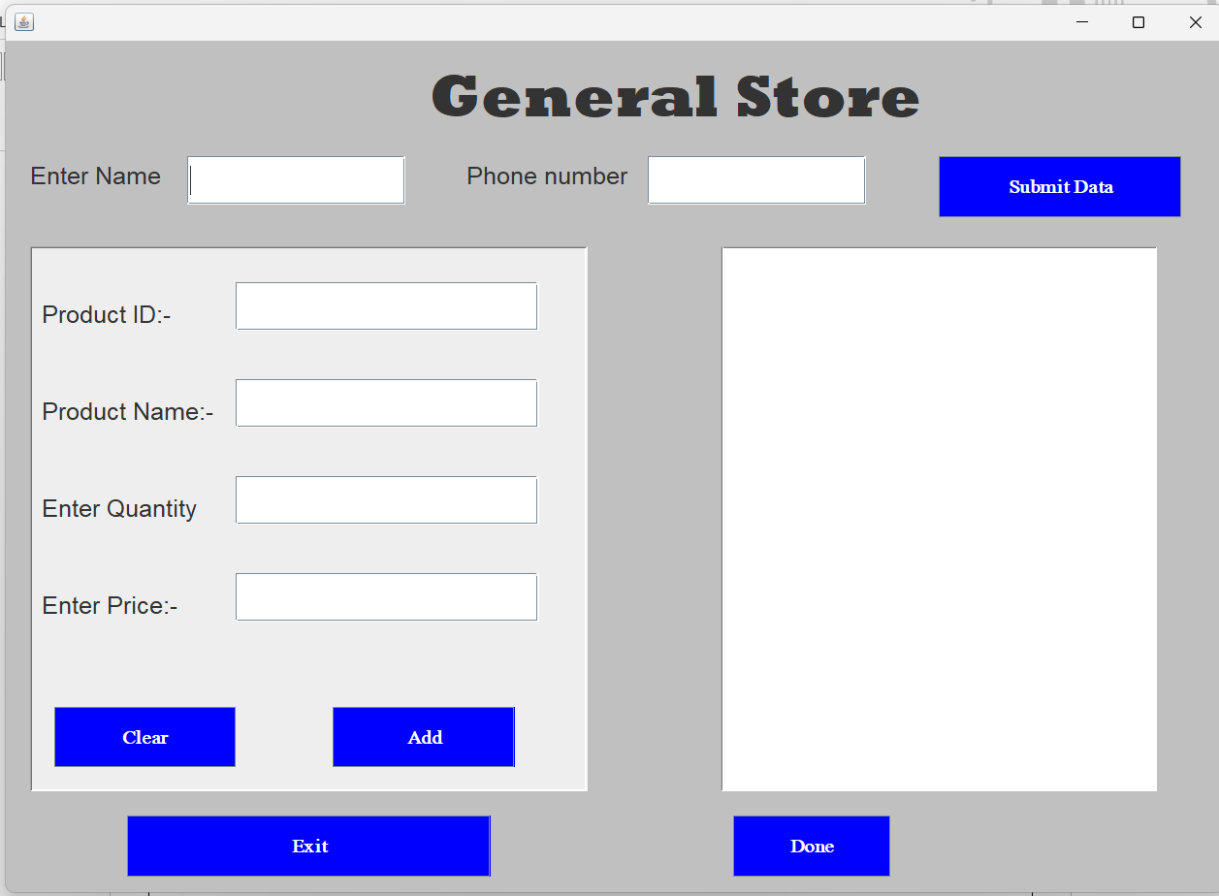

**OVERALL PROJECT VIEW:**

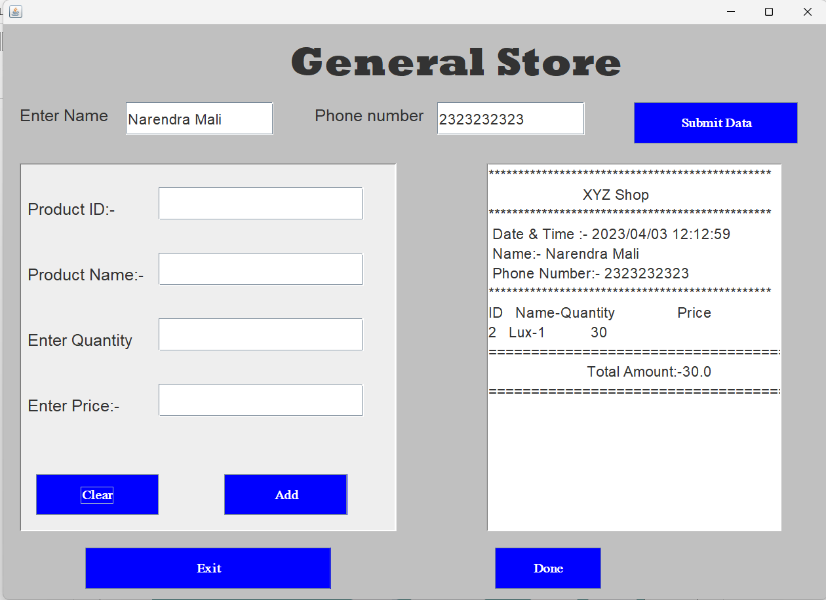

**CODE(PREVIEW):**

import javax.swing.*;  
import java.awt.*;  
import java.awt.event.ActionEvent;  
import java.awt.print.PrinterException;  
import java.time.format.DateTimeFormatter;  
import java.time.LocalDateTime;  
import java.util.ArrayList;  
import java.lang.*;  
  
public class BillingSystem extends JFrame  
{  
 ArrayList<Double> amount = new ArrayList<Double>();  
 public JTextArea textArea;  
 JButton submitdata, download_pdf, doneTextArea, intotextarea, clearpanel,done;  
 JLabel customername,customerphone,item_Id,item_name, quantity, price;  
 JTextField entername, enterphone,enterID,enter_productName,enterQuantity,enter_price;  
 //JTextArea textArea;  
 DateTimeFormatter dtf = DateTimeFormatter.*ofPattern*("yyyy/MM/dd HH:mm:ss");  
 LocalDateTime now = LocalDateTime.*now*();  
 BillingSystem()  
 {  
 setBounds(300,100,1020,740);  
 getContentPane().setBackground(Color.*LIGHT_GRAY*);  
  
 JLabel mainheading = new JLabel("General Store");  
 mainheading.setBounds(350,20,500,50);  
 mainheading.setFont(new Font("Rockwell Extra Bold",Font.*PLAIN*,50));  
 add(mainheading);  
  
 customername = new JLabel("Enter Name");  
 customername.setBounds(20,86,500,50);  
 customername.setFont(new Font("Charcoal CY",Font.*PLAIN*,20));  
 add(customername);  
  
 entername = new JTextField();  
 entername.setBounds(150,96,180,40);  
 entername.setFont(new Font("Charcoal CY",Font.*PLAIN*,18));  
 add(entername);  
  
 customerphone = new JLabel("Phone number");  
 customerphone.setBounds(380,86,200,50);  
 customerphone.setFont(new Font("Charcoal CY",Font.*PLAIN*,20));  
 add(customerphone);  
  
 enterphone = new JTextField();  
 enterphone.setBounds(530,96,180,40);  
 enterphone.setFont(new Font("Charcoal CY",Font.*PLAIN*,18));  
 add(enterphone);  
  
 submitdata = new JButton("Submit Data");  
 submitdata.setBounds(770,96,200,50);  
 submitdata.setFocusable(false);  
 submitdata.setFont(new Font("Mongolian Baiti",Font.*BOLD*,16));  
 submitdata.setBackground(Color.*blue*);  
 submitdata.setForeground(Color.*WHITE*);  
 add(submitdata);  
 submitdata.addActionListener(this::submit_Button_Action);  
  
 textArea = new JTextArea();  
 textArea.setBounds(590,170,360,450);  
 textArea.setFont(new Font("Charcoal CY",Font.*PLAIN*,18));  
 textArea.setBorder(BorderFactory.*createBevelBorder*(1));  
 add(textArea);  
  
 doneTextArea = new JButton("Done");  
 doneTextArea.setBounds(600,640,130,50);  
 doneTextArea.setFocusable(false);  
 doneTextArea.setFont(new Font("Mongolian Baiti",Font.*BOLD*,16));  
 doneTextArea.setBackground(Color.*blue*);  
 doneTextArea.setForeground(Color.*WHITE*);  
 doneTextArea.addActionListener(this::done_TextArea_Action);  
 add(doneTextArea);  
  
  
  
  
 JPanel panel = new JPanel();  
 panel.setBounds(20,170,460,450);  
 panel.setBorder(BorderFactory.*createBevelBorder*(1));  
 panel.setLayout(null);  
 add(panel);  
  
 item_Id = new JLabel("Product ID:-");  
 item_Id.setBounds(10,30,200,50);  
 item_Id.setFont(new Font("Charcoal CY",Font.*PLAIN*,20));  
 panel.add(item_Id);  
  
 enterID = new JTextField();  
 enterID.setBounds(170,30,250,40);  
 enterID.setFont(new Font("Charcoal CY",Font.*PLAIN*,18));  
 panel.add(enterID);  
  
 item_name = new JLabel("Product Name:-");  
 item_name.setBounds(10,110,200,50);  
 item_name.setFont(new Font("Charcoal CY",Font.*PLAIN*,20));  
 panel.add(item_name);  
  
 enter_productName = new JTextField();  
 enter_productName.setBounds(170,110,250,40);  
 enter_productName.setFont(new Font("Charcoal CY",Font.*PLAIN*,18));  
 panel.add(enter_productName);  
  
 quantity = new JLabel("Enter Quantity");  
 quantity.setBounds(10,190,200,50);  
 quantity.setFont(new Font("Charcoal CY",Font.*PLAIN*,20));  
 panel.add(quantity);  
  
 enterQuantity = new JTextField();  
 enterQuantity.setBounds(170,190,250,40);  
 enterQuantity.setFont(new Font("Charcoal CY",Font.*PLAIN*,18));  
 panel.add(enterQuantity);  
  
 price = new JLabel("Enter Price:-");  
 price.setBounds(10,270,200,50);  
 price.setFont(new Font("Charcoal CY",Font.*PLAIN*,20));  
 panel.add(price);  
  
 enter_price = new JTextField();  
 enter_price.setBounds(170,270,250,40);  
 enter_price.setFont(new Font("Charcoal CY",Font.*PLAIN*,18));  
 panel.add(enter_price);  
  
 clearpanel= new JButton("Clear");  
 clearpanel.setBounds(20,380,150,50);  
 clearpanel.setFont(new Font("Mongolian Baiti",Font.*BOLD*,16));  
 clearpanel.setBackground(Color.*blue*);  
 clearpanel.setForeground(Color.*WHITE*);  
 clearpanel.addActionListener(new java.awt.event.ActionListener()  
 {  
 public void actionPerformed(ActionEvent evt)  
 {  
 clearpanel_Button_Action(evt);  
 }  
 });  
 panel.add(clearpanel);  
  
 done= new JButton("Add");  
 done.setBounds(250,380,150,50);  
 done.setFont(new Font("Mongolian Baiti",Font.*BOLD*,16));  
 done.setBackground(Color.*blue*);  
 done.setForeground(Color.*WHITE*);  
 done.addActionListener(new java.awt.event.ActionListener()  
 {  
 public void actionPerformed(ActionEvent evt)  
 {  
 done_Button_Action(evt);  
 }  
 });  
 panel.add(done);  
  
 intotextarea = new JButton("Exit");  
 intotextarea.setBounds(100,640,300,50);  
 intotextarea.setFont(new Font("Mongolian Baiti",Font.*BOLD*,16));  
 intotextarea.setBackground(Color.*blue*);  
 intotextarea.setForeground(Color.*WHITE*);  
 intotextarea.addActionListener(this::Exit_Button_Action);  
 add(intotextarea);  
  
  
 setLayout(null);  
 setDefaultCloseOperation(*EXIT_ON_CLOSE*);  
 setVisible(true);  
 }  
  
  
  
 private void clearpanel_Button_Action(ActionEvent evt)  
 {  
 enter_price.setText(null);  
 enterID.setText(null);  
 enter_productName.setText(null);  
 enterQuantity.setText(null);  
 }  
  
 private void Exit_Button_Action(ActionEvent evt)  
 {  
 System.*exit*(0);  
 }  
  
  
 private void done_Button_Action(ActionEvent evt)  
 {  
 if (enterID.getText().isEmpty() && enter_productName.getText().isEmpty() && enterQuantity.getText().isEmpty() && enter_price.getText().isEmpty())  
 {  
 JOptionPane.*showMessageDialog*(null, "Please Enter Products Details","Getting Error", JOptionPane.*ERROR_MESSAGE*);  
 }  
 else {  
 String productId = String.*format*(enterID.getText());  
 String productname = String.*format*(enter_productName.getText());  
 String productprice = String.*format*(enter_price.getText());  
 int productquantity = Integer.*parseInt*(enterQuantity.getText());  
 amount.add(Double.*parseDouble*(enter_price.getText()));  
 textArea.append("\n" + productId + " " + productname + "-" + productquantity + "\t " + productprice);  
 }  
 }  
  
 private void done_TextArea_Action(ActionEvent evt)  
 {  
  
 Double totalamount = 0.0;  
 for (Double i : amount) {  
 totalamount += i;  
 }  
 textArea.append("\n============================================" +  
 "\n\t Total Amount:-" + totalamount +  
 "\n=============================================");  
  
  
 }  
  
 private void submit_Button_Action(ActionEvent evt)  
 {  
 if (entername.getText().isEmpty() && enterphone.getText().isEmpty())  
 {  
 JOptionPane.*showMessageDialog*(null, "Please Enter Customer Details","Getting Error", JOptionPane.*ERROR_MESSAGE*);  
 }  
 else  
 {  
 String name = String.*format*(entername.getText());  
 String phone = String.*format*(enterphone.getText());  
 textArea.append("************************************************" +  
 "\n\tXYZ Shop\t" +  
 "\n************************************************" +  
 "\n Date & Time :- " + dtf.format(now) +  
 "\n Name:- " + name +  
 "\n Phone Number:- " + phone +  
 "\n************************************************" +  
 "\nID Name-Quantity\tPrice");  
 }  
 }  
  
 private void download_pdf_Button_Action(ActionEvent evt)  
 {  
 try {  
 textArea.print();  
 } catch (PrinterException e) {  
 e.printStackTrace();  
 }  
 }  
  
 public static void main(String[] args)  
 {  
 new BillingSystem();  
  
  
 }  
  
}